Experiment 6
Aim
Kubernetes Services & Networking
Theory
Kubernetes Service is an abstraction that provides a stable network endpoint for accessing a group of Pods. Since Pods are temporary and their IP addresses can change, Services provide stable connectivity and distribute requests among matching Pods.
Types of Kubernetes Services
Service | Accessibility | Use
ClusterIP | Inside cluster | Internal communication
NodePort | Outside cluster via node IP and port | Development/testing
LoadBalancer | Outside cluster via external load balancer | Cloud deployments

1. ClusterIP
- Default Service type in Kubernetes.
- Provides a stable IP and DNS name within the cluster.
- Not directly accessible from outside the cluster.
- Can be tested using port forwarding.
2. NodePort
- Exposes a Service on a fixed port on each Kubernetes node.
- Accessible externally using the Node IP + NodePort.
- Useful for development and testing.
- In this experiment, 80 is the Service port and 30080 is the NodePort.
3. LoadBalancer
- Exposes a Service through an external load balancer.
- Commonly used in cloud environments.
- In Minikube, minikube tunnel provides LoadBalancer functionality locally.
- The Service distributes incoming requests among the NGINX Pods.
Service-to-Pod Connection
A Service uses a selector such as:
selector:
app: nginx

It identifies all Pods having the matching label and forwards traffic to their Endpoints. In this experiment: an NGINX Deployment with 3 replicas is exposed using ClusterIP, NodePort, and LoadBalancer Services, demonstrating different methods of networking and accessing Kubernetes applications.
Execution
#nginx-deployment.yaml
apiVersion: apps/v1
kind: Deployment
metadata:
name: nginx-deployment
spec:
replicas: 3
selector:
matchLabels:
app: nginx
template:
metadata:
labels:
app: nginx
spec:
containers:
- name: nginx
image: nginx
ports:
- containerPort: 80

#clusterip-service.yaml
apiVersion: v1
kind: Service
metadata:
name: nginx-clusterip
spec:
type: ClusterIP
selector:
app: nginx
ports:
- protocol: TCP
port: 80
targetPort: 80

#nodeport-service.yaml
apiVersion: v1
kind: Service
metadata:
name: nginx-nodeport
spec:
type: NodePort
selector:
app: nginx
ports:
- protocol: TCP
port: 80
targetPort: 80
nodePort: 30080

#loadbalancer-service.yaml
apiVersion: v1
kind: Service
metadata:
name: nginx-loadbalancer
spec:
type: LoadBalancer
selector:
app: nginx
ports:
- protocol: TCP
port: 80
targetPort: 80

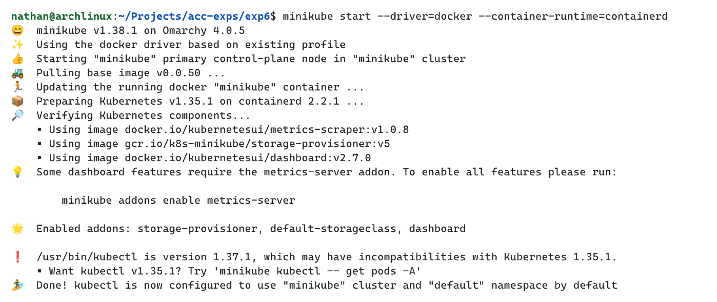

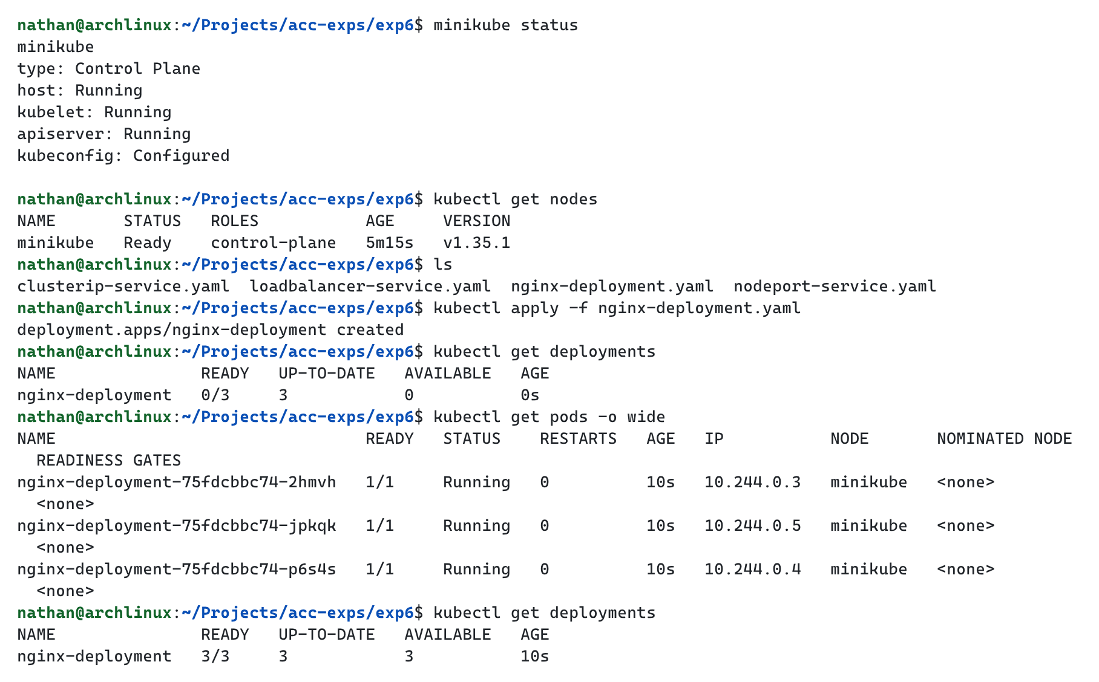

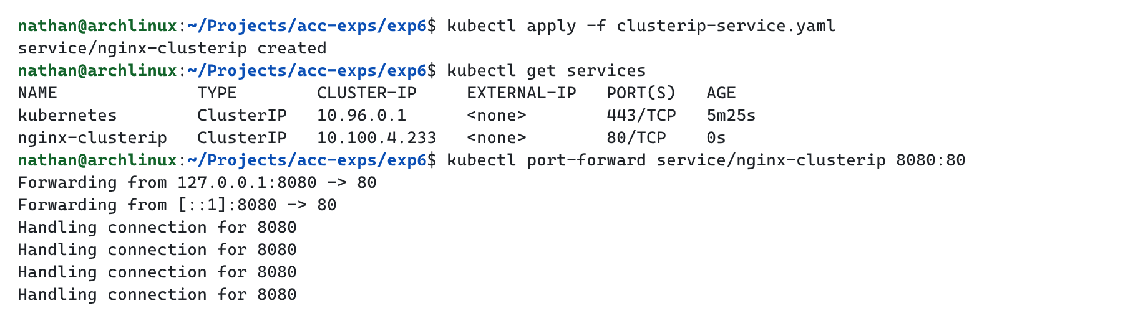

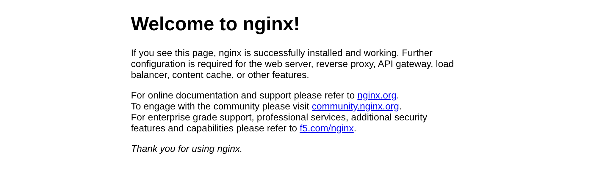

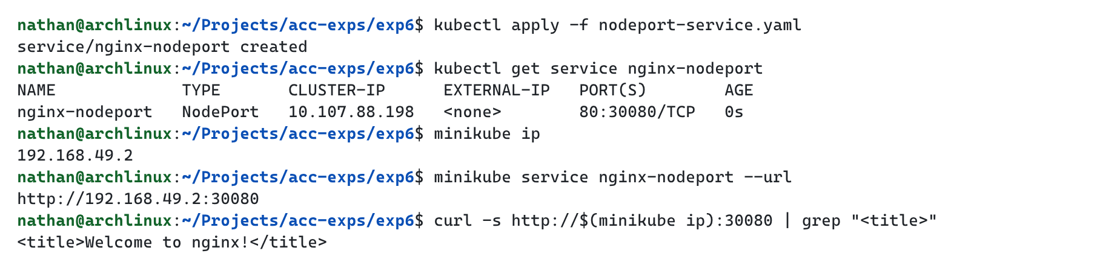

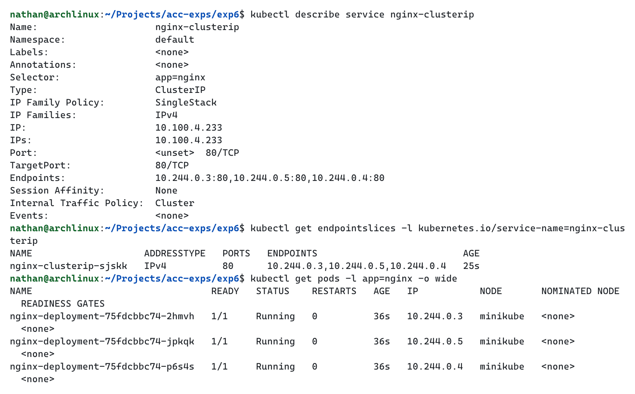

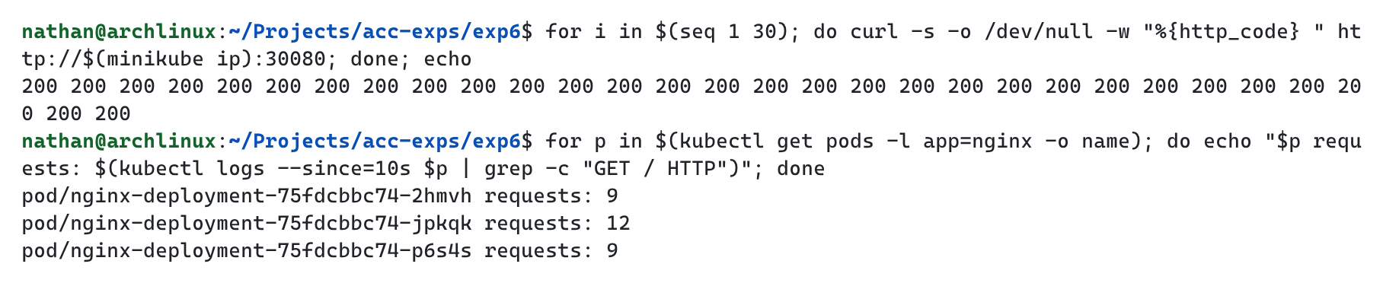

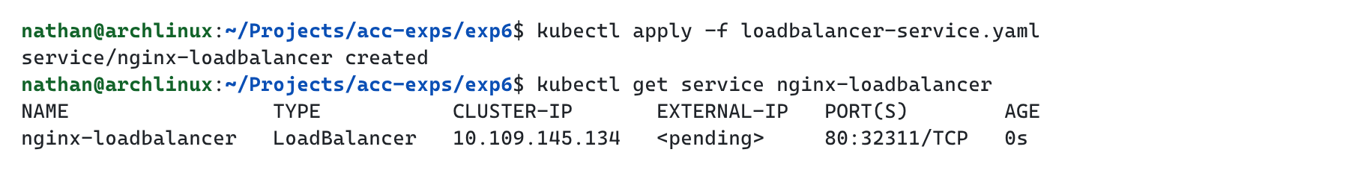

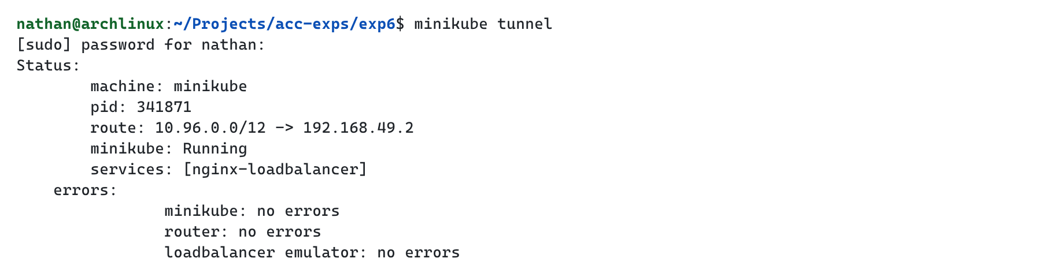

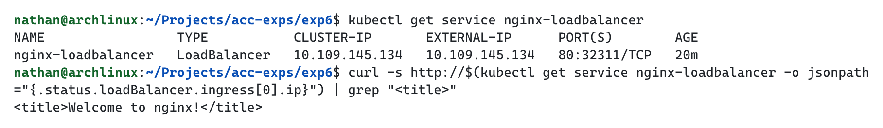

Conclusion
Thus, the experiment successfully demonstrated Kubernetes Services and Networking using NGINX. ClusterIP, NodePort, and LoadBalancer Services were created and tested to understand different methods of exposing applications. The experiment also verified Service-to-Pod communication, stable networking, and load balancing among multiple Pods.

